New Alpha Factor Determination as a Function of
Number of Wheels and Number of Coverages

Letter Report

Prepared
by

Gordon F. Hayhoe
Airport Technology Research and Development Branch
AJP 6310 (AAR-410)

Submitted
to

Associate Administrator for Airports
Office of the Director, Airport Safety and Standards
AAS-1

November 16, 2006

1. INTRODUCTION.

The International Civil Aviation Organization (ICAO) has proposed that the Alpha Factors for four- and six-wheel gears at 10,000 Coverages be redefined for use in calculating the Aircraft Classification Number (ACN) of airplanes operating on flexible pavements. The proposed Alpha Factors are 0.800 and 0.720 and the existing values are 0.825 and 0.788, with the new values being based on an analysis of a recently expanded set of full-scale test data for four- and six-wheel traffic. With these changes, Alpha Factors at other numbers of wheels, and over the full range of coverages for design, also require redefinition to maintain consistency in the CBR (California Bearing Ratio) procedure for flexible pavement thickness design as required for ACN calculations, even though additional full-scale test data is not available for other than four- and six-wheel gears.

A new set of Alpha Factors at 10,000 Coverages is defined first based on recommendations contained in ICAO AOSWG/4 Discussion Paper No. 21. A new set of functions is then defined to allow the calculation of Alpha Factor over the full range of Coverages expected in flexible pavement thickness design for commercial airplane operations. The new set of functions defining Alpha Factor versus Coverages is compatible with the new set of Alpha Factors at 10,000 Coverages. The functions are also compatible, to the extent possible, with existing definitions of Alpha Factor versus Coverages.

2. ALPHA FACTOR AT 10,000 COVERAGES VERSUS NUMBER OF WHEELS.

The Alpha Factors embedded in ICAO Computer Program No. 2 for calculating flexible pavement ACN values for 1, 2, 4, 6, 8, 12, 18, and 24 wheels (reference 1) are listed in table 1 and shown graphically in figure 1.

Table 1. Alpha factors embedded in ICAO Computer Program No. 2, Flexible Pavement ACN.
Number of Wheels | Alpha Factor from ICAO Computer Program No. 2
1 | 0.995
2 | 0.900
4 | 0.825
6 | 0.788
8 | 0.755
12 | 0.722
18 | 0.700
24 | 0.689

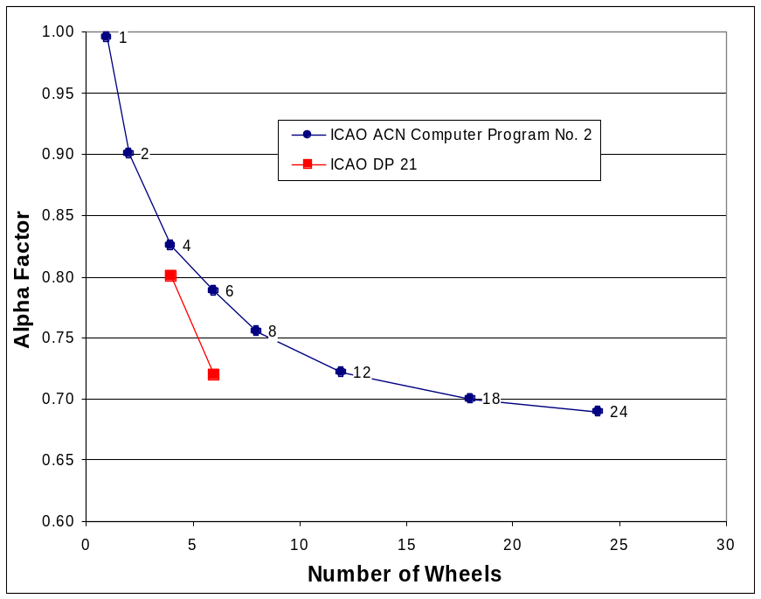
Figure 1. Alpha factors embedded in ICAO Computer Program No. 2, Flexible Pavement ACN, with recommended changes for 4- and 6-wheel airplanes.

ICAO AOSWG/4 Discussion Paper No. 21 (DP21) recommends that the following change be made to the Alpha Factors for the computation of ACN values:

- Change the Alpha Factors for all 4-wheel and 6-wheel aircraft (0.80 and 0.71/0.72), and alter the Alpha Factors for other wheel numbers so that the ranking of damaging effect is consistent. ACNs for all aircraft would change, and the Alpha Factors would be technically correct.

Figure 1 also shows the new Alpha Factors for 4- and 6-wheel airplanes as well as the original Alpha Factors.

The Alpha Factors in table 1 were originally derived from curves of Alpha Factor versus Coverages published in references 2 and 3 for gears with 1, 2, 4, 6, 8, 12 18, and 24 wheels. Reference 2 published the 1-, 4-, and 12-wheel curves based on full-scale test data for single, dual tandem, and two C-5 six-wheel gears in tandem (for the 12-wheel gear curve). Reference 3 added the additional curves by interpolation (for 2-, 6-, and 8-wheel gears) and extrapolation (for 18- and 24-wheel gears). Extrapolation outside the range of the existing full-scale test data was important because the CBR design procedure as defined in reference 4 requires that pavement thickness be computed for all combinations of wheels in the main landing gear, and that the largest of these thicknesses be used for design. Quoting the relevant passage from reference 4 (pages 70 and 71):

“The α_{i} curves have been developed using the load on one landing gear assembly of an aircraft. In actual practice, designs are to be based upon the load on all main tires. Therefore, the α_{i} versus passes curves (figure 82) show the total number of aircraft main gear tires represented by the gear type. Use of the criteria, therefore, is accomplished by determining the ESWL and the α_{i} for all main gear tires, which generally results in maximum thickness requirements for a specific aircraft. However, where it is shown that some combination or grouping of tires other than all main gear tires will produce a greater thickness requirement, then the other combination or group will be used.”

Reference 3 (page 27) contains a similar statement:

“The number of tires used to compute the ESWL is that combination of tires which gives the greatest ESWL …”

These two statements are not necessarily consistent, but the intent is clear. In particular, the pavement thickness design charts for the B747 airplane published in Federal Aviation Administration (FAA) AC 150/5320-6C and -6D are based on equivalent single wheel loads (ESWLs) computed using 16 wheels and Alpha Factor curves for 16 wheels.

Looking at figure 1, it is clear that, in order to integrate the new Alpha Factors (0.8 and 0.72) into the Aircraft Classification Number – Pavement Classification Number (ACN-PCN) system, adjustments need to be made to the Alpha Factors for wheel numbers other than 4 and 6. The 1-wheel Alpha Factor is based on a reasonably large set of full-scale tests (see reference 2) and there does not appear to be a compelling reason to change it. The 2-wheel Alpha Factor was based on interpolation between the 1-wheel and 4-wheel Alpha Factor curves and it seems reasonable to also not change its value, although a reduction in its value proportionate to the reduction of the 4-wheel value from 0.825 to 0.80 would also be reasonable. That is, a new Alpha Factor for 2 wheels which has the same proportions relative to the new 1- and 4-wheel Alpha Factors as the old 2-wheel Alpha Factor has to the old 1- and 4-wheel Alpha Factors could be defined by:

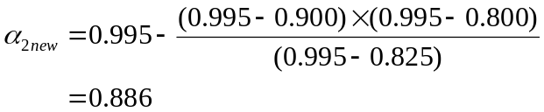 (1)

The remaining Alpha Factors, for 8 wheels and above, have no basis in full-scale test data except that the C5 test data had originally been treated as a 12-wheel gear. This formed the basis for the old 12-wheel Alpha Factor with the old 6-wheel Alpha Factor being an interpolation between the 4- and 12-wheel values. But after test data had been collected with a triple-dual-tandem (3D) gear at higher coverage levels than for the C5 tests, the C5 was re-categorized as two 6-wheel gears in tandem so that the two data sets could be combined (see reference 5 for more details). As stated above, ICAO AOSWG/4 DP 21 recommends that undefined new Alpha Factors be altered “so that the ranking of damaging effect is consistent.” The Alpha Factors for 8 wheels and above have therefore been adjusted so that the ratio of ACN relative to the ACN for a 6-wheel gear is, to a very good approximation, the same in the new system as in the old. The equation used to calculate the new Alpha Factors is:

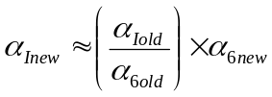 (2)

where:

α_{Iold} = | old Alpha Factor for I number of wheels as listed in table 1 for I = 8, 12, 18, and 24
α_{6old} = | old Alpha Factor for 6 wheels = 0.788 as listed in table 1
α_{6new} = | new Alpha Factor for 6 wheels = 0.72

Equation 2 is derived in a separate section below.

Table 2 shows the new alpha factors as defined by full-scale test data (1, 2, 4, and 6 wheels) and from equation 2 (8, 12, 18, and 24 wheels).

Table 2. New Alpha factors at 10,000 Coverages.
Number of Wheels | New Alpha Factor
1 | 0.995
2 | 0.900
4 | 0.800
6 | 0.720
8 | 0.690
12 | 0.660
18 | 0.640
24 | 0.630

In order to determine values of Alpha Factor for numbers of wheels other than those in table 2, a curve fitting or interpolation scheme is needed. A curve fitting computer program (CurveExpert 1.3) was used to find equations describing the relationship between Alpha Factor (at 10,000 Coverages) versus number of wheels. The best fit equation for the old Alpha Factors had the form

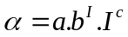 (3)
where:

α = | Alpha Factor
I = | number of wheels
a, b, and c = | curve fitting coefficients

Figure 2 shows the old and new Alpha Factors with curve fits for equation 3 also shown. The curve fit for the old Alpha Factors is very good, but that for the new Alpha Factors is poor, particularly over the critical range of 2 to 12 wheels. This curve fit cannot therefore be used to compute Alpha Factor without either giving inaccurate values for the defined points (when the defined points are computed with the curve fit equation) or giving inaccurate relative values between undefined and defined points (when the undefined points are computed with the curve fit equation and the defined values are used for the defined points). Other equations give better correlation coefficients for the new Alpha Factors, but none satisfactorily solve the problem described in the previous sentence. A simple linear interpolation is therefore proposed for computing the Alpha Factor values for numbers of wheels between those defined in table 2.

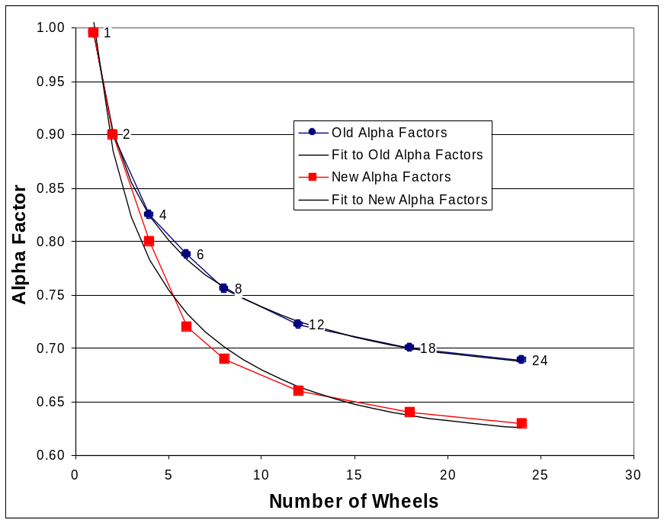
Figure 2. Old and new Alpha Factors with curve fits.

2.1 DERIVATION OF EQUATION 3. The CBR equation used for thickness design in the CBR method for airport pavements is:

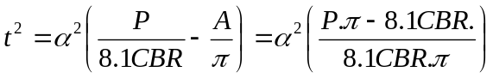 (4)

Where:
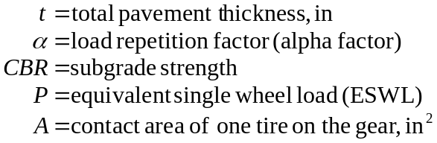

To keep the ratio of ACN for I wheels to ACN for 6 wheels in the new system to be the same as in the old system:

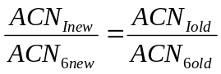 (5)

The definition of ACN (reference 1) is:

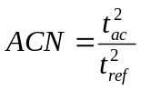 (6)

Where:

and therefore:

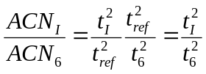 (7)

Substituting for t from equation 4 (the CBR equation):

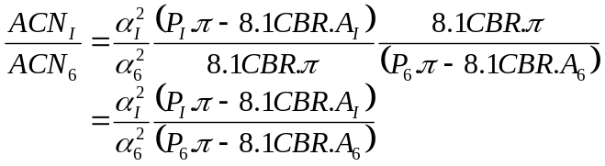 (8)

The second terms in the parentheses are small compared to the first terms, and:

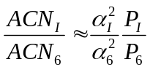 (9)

Now, from equation 5:

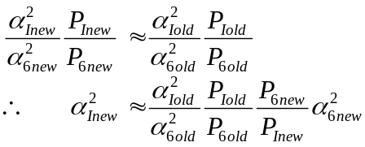 (10)

This equation does not have an explicit solution because P changes with pavement thickness and pavement thickness changes with Alpha Factor. However, as is demonstrated below in a numerical example, the term 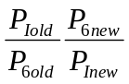 has a value close to one and, to a first approximation, equation 10 can be simplified to

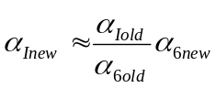

Which is the relationship used above (equation 2) to generate the new Alpha Factors listed in table 2 for 8, 12, 18, and 24 wheels.

2.2 NUMERICAL EXAMPLES. Two numerical examples are worked through to establish how well the new Alpha Factors for 8, 12, 18, and 24 wheels maintain the same relative ACN ratios as in the old system. The first example compares two C5 airplane gear configurations. The first configuration consists of one six-wheel gear and the second configuration consists of two six-wheel gears in tandem. The two-gear configuration is treated as a twelve-wheel gear for ACN computation. The second example compares a triple-dual-tandem (3D) six-wheel configuration with a 5D ten-wheel configuration. Both configurations have the same dual and tandem wheel spacing and the 3D configuration is close to B777-300 gear geometry and wheel loading. These two examples represent two extremes of wheel configuration and wheel loading.

2.2.1 Example 1 – C5 Landing Gear. Figures 3 and 4 show the wheel configurations for the six- and twelve-wheel cases. Gear geometry is standard and wheel loads are 30,000 lbs (133 kN). COMFAA was used to calculate ACNs with both the old and the new Alpha Factors. Tables 3 and 4 list the results for 3 CBR and 15 CBR, together with pavement thicknesses and equivalent single-wheel loads (ESWLs). The ACN ratios for old and new Alpha Factors are summarized in table 5.

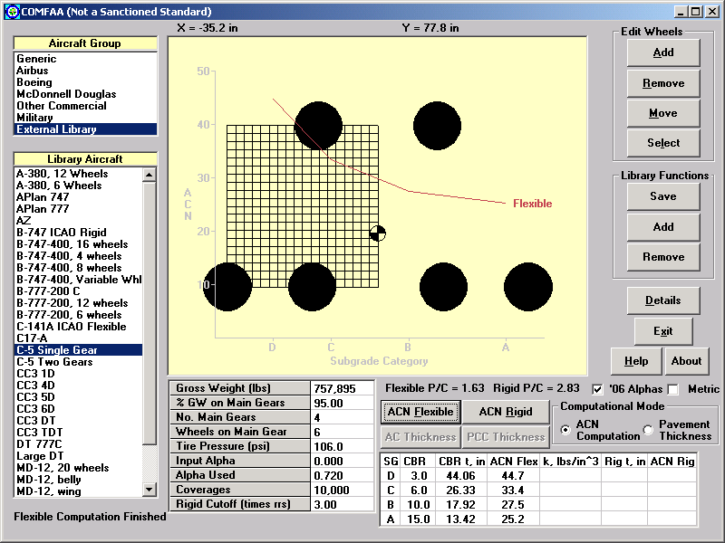
Figure 3. COMFAA screen shot showing C5 single-gear six-wheel configuration.

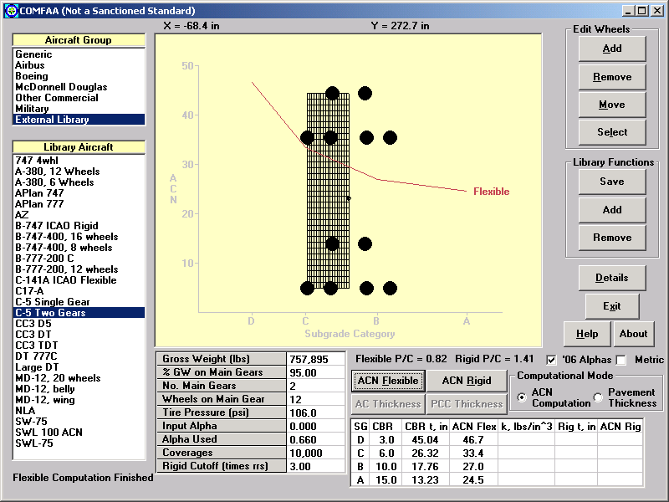
Figure 4. COMFAA screen shot showing C5 double-gear twelve-wheel configuration.

Table 3. C5 ACN results for old Alpha Factors
Gear Configuration | CBR | ACN | Pavement Thickness, in | Pavement Thickness Squared, in² | ESWL,  lbs
12-Wheel | 3 | 61.7 | 51.75 | 2,678 | 127,111
6-Wheel | 3 | 58.7 | 50.47 | 2,547 | 101,903
Ratio 12Whl:6Whl |  | 1.051 | 1.025 | 1.051 | 1.247
12-Wheel | 15 | 30.9 | 14.84 | 220.2 | 61,702
6-Wheel | 15 | 31.3 | 14.96 | 223.8 | 54,280
Ratio 12Whl:6Whl |  | 0.987 | 0.992 | 0.984 | 1.137

Table 4. C5 ACN results for new Alpha Factors
Gear Configuration | CBR | ACN | Pavement Thickness, in | Pavement Thickness Squared, in² | ESWL,  lbs
12-Wheel | 3 | 46.7 | 45.04 | 2,029 | 115,349
6-Wheel | 3 | 44.7 | 44.06 | 1,941 | 93,257
Ratio 12Whl:6Whl |  | 1.045 | 1.022 | 1.045 | 1.237
12-Wheel | 15 | 24.5 | 13.23 | 175.0 | 59,126
6-Wheel | 15 | 25.2 | 13.42 | 180.1 | 52,403
Ratio 12Whl:6Whl |  | 0.972 | 0.986 | 0.972 | 1.128

Table 5. ACN and ESWL ratios (12Whl:6Whl) for C5 gears (from tables 3 and 4)
CBR | ACN Ratio with  Old Alpha Factors | ACN Ratio with  New Alpha Factors | Percent  Difference | 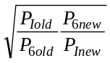
3 | 1.051 | 1.045 | 0.6 | 1.0042
15 | 0.987 | 0.972 | 1.5 | 1.0037

2.2.2 Example 2 – 3D and 5D Landing Gear. Figures 5 and 6 show the wheel configurations for the six- and ten-wheel 3D and 5D gears. Gear geometry is 54 inches dual spacing and 57 inches tandem spacing. Wheel loads are 55,000 lbs (245 kN). Tables 6 and 7 list the results for 3 CBR and 15 CBR, together with pavement thicknesses and equivalent single-wheel loads (ESWLs). The ACN ratios for old and new Alpha Factors are summarized in table 8.

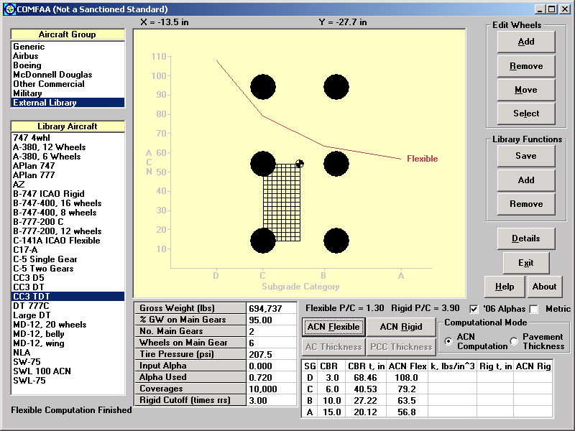
Figure 5. COMFAA screen shot showing 3D six-wheel gear.

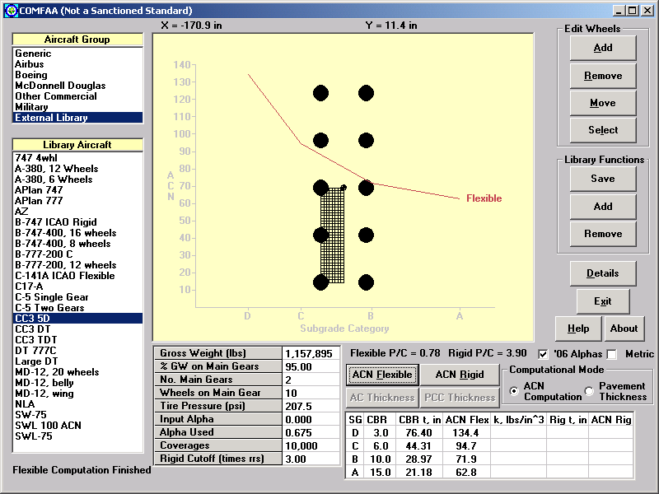
Figure 6. COMFAA screen shot showing 5D ten-wheel gear.

Table 6. 3D and 5D ACN results for old Alpha Factors
Gear Configuration | CBR | ACN | Pavement Thickness, in | Pavement Thickness Squared, in² | ESWL,  lbs
10-Wheel | 3 | 174.1 | 86.92 | 7,555 | 338,278
6-Wheel | 3 | 137.8 | 77.35 | 5,983 | 235,986
Ratio 10Whl:6Whl |  | 1.263 | 1.124 | 1.263 | 1.433
10-Wheel | 15 | 81.1 | 24.06 | 578.9 | 139,310
6-Wheel | 15 | 72.5 | 22.75 | 517.6 | 111,887
Ratio 10Whl:6Whl |  | 1.119 | 1.0576 | 1.118 | 1.245

Table 7. 3D and 5D ACN results for new Alpha Factors
Gear Configuration | CBR | ACN | Pavement Thickness, in | Pavement Thickness Squared, in² | ESWL,  lbs
10-Wheel | 3 | 134.4 | 76.40 | 5,837 | 313,265
6-Wheel | 3 | 108.0 | 68.46 | 4,687 | 221,748
Ratio 10Whl:6Whl |  | 1.244 | 1.116 | 1.245 | 1.413
10-Wheel | 15 | 62.8 | 21.18 | 448.6 | 129,780
6-Wheel | 15 | 56.8 | 20.12 | 404.8 | 105,625
Ratio 10Whl:6Whl |  | 1.106 | 1.0527 | 1.108 | 1.229

Table 8. ACN and ESWL ratios for 3D and 5D Gears (from tables 6 and 7)
CBR | ACN Ratio with  Old Alpha Factors | ACN Ratio with  New Alpha Factors | Percent  Difference
3 | 1.263 | 1.244 | 1.5 | 1.0073
15 | 1.119 | 1.106 | 1.2 | 1.0067

In both examples, the ACN ratios for the new Alpha Factors are consistently higher than those for the old Alpha Factors, but by less than 2 percent. The discrepancies are presumably due to the approximations made in deriving equation 2 and, for the second example, the linear interpolation between eight- and twelve-wheel values. To determine the order of the errors in the new Alpha Factors, the new Alpha Factor for twelve wheels in example 1 was adjusted until the ACN ratio for the new Alpha Factors at 3 CBR was the same as the ACN ratio for the old Alpha Factors at 3 CBR. This resulted in a corrected twelve-wheel Alpha Factor value of 0.661 instead of the value of 0.660 from table 2. Performing the same process for example 2 resulted in a corrected ten-wheel Alpha Factor value of 0.678 instead of the value of 0.675 found by interpolating between the eight- and twelve-wheel Alpha Factors in table 2. These differences are negligible and it is recommended that the values in table 2 be used for the new Alpha Factors at the indicated number of wheels and that intermediate values be found by linear interpolation.

Also of note is that the six-wheel gear has a lower ACN than the gear with more than six wheels in example 1 at 3 CBR and in example 2 at both 3 and 15 CBR. But the ACN of the six-wheel gear is higher than the ACN of the twelve-wheel gear in example 1. A major difference in the examples is that the twelve-wheel C5 configuration has two groups of six wheels spaced a considerable distance apart whereas the wheels in the ten-wheel gear of example 2 all have the same tandem spacing as the wheels in the six-wheel gear. In order to get a clearer picture of the variation of ACN with number of wheels, a B747 configuration was set up with sixteen wheels in the main landing gear (see figure 7). ACN was computed for the initial configuration and repeatedly after removing single wheels in the group until only one wheel remained. Wheels were removed from right to left in one case and from the left and right sides towards the center in another case. In a third case, the 5D gear of figure 6 was extended to a 6D twelve-wheel gear and ACN computed as pairs of wheels were removed from one end of the gear to the other. Figures 8, 9, and 10 show the results.

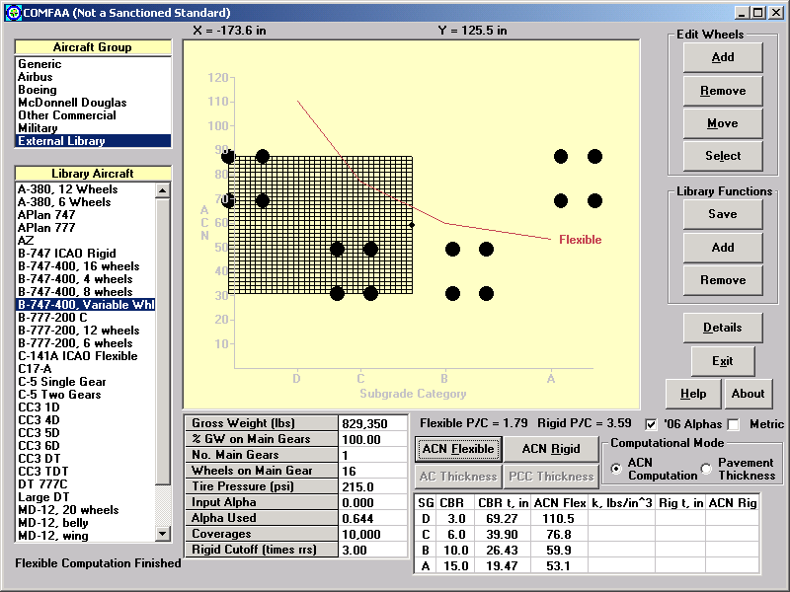
Figure 7. COMFAA screen shot showing B747 16-wheel landing gear.

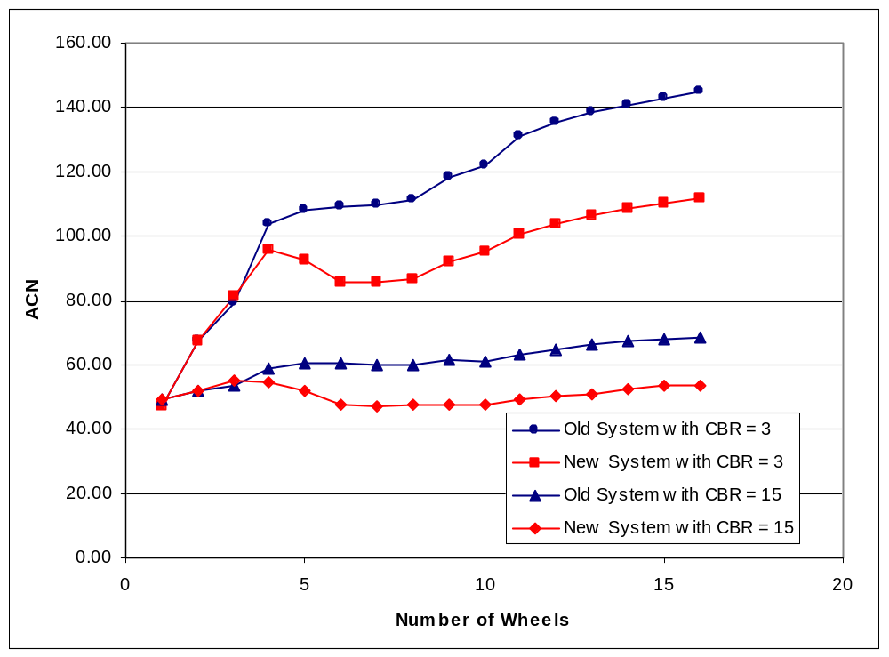
Figure 8. ACNs for B747 configuration. Wheels removed from right to left.

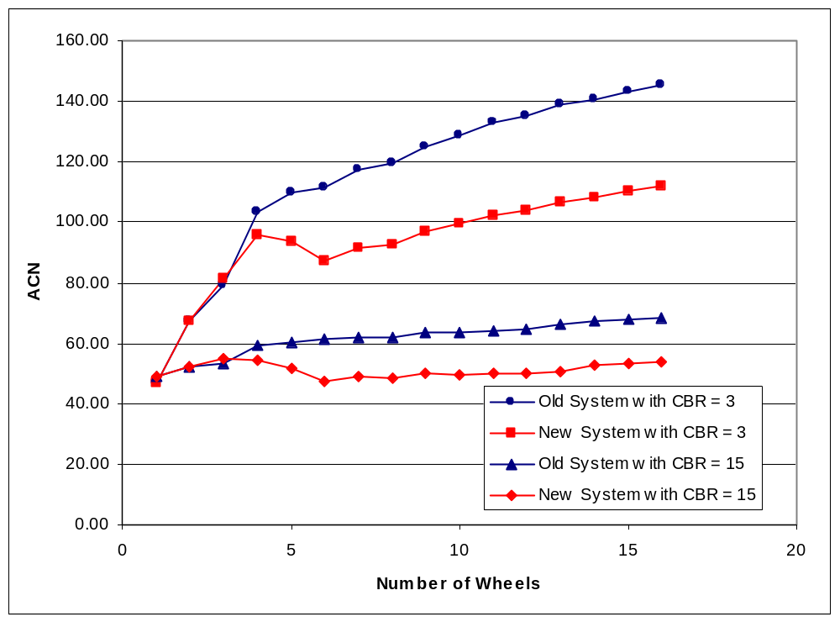
Figure 9. ACNs for B747 configuration. Wheels removed from the outside to the center.

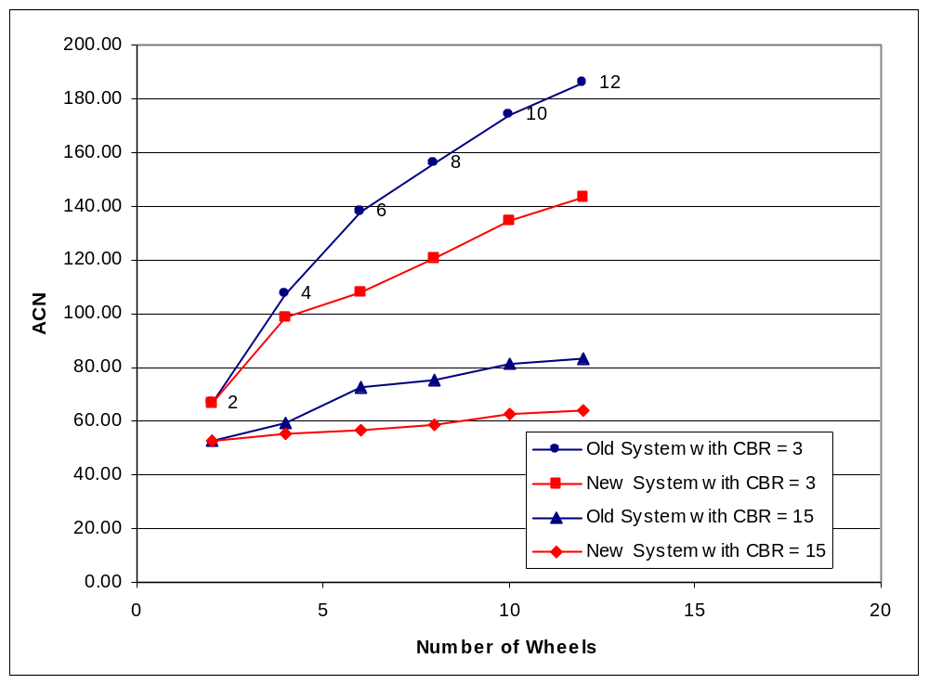
Figure 10. ACNs for a 6D configuration. Wheels removed in pairs from one end to the other.

In figure 8, with the 747 wheels removed from right to left, the old system gives ACN values which decrease almost continuously from 16 wheels to 1 wheel (the curve is almost flat from eight to five wheels). But with the new system, the ACN values decrease continuously from sixteen to six wheels and then increase significantly from six to four wheels before decreasing from four to one wheel (with almost the same values as with the old system, as is to be expected). This local minimum does not make physical sense unless the procedure is considered to be exhibiting the same kind of behavior noted in reference 6, which was caused by reversals in vertical strain damage computations with distance from the point of load application. The ACN values in figure 9, with the 747 wheels removed from the outside inward, show similar trends, but less extreme.

In figure 10, with dual wheels removed from the 6D gear from one end to the other, the old and new systems both show continuously decreasing ACN values. The old system shows a smoother curve than the new system at 3 CBR, but the reverse is the case at 15 CBR, indicating yet again that the Alpha Factor system, as implemented in the CBR design procedure, cannot account for the effects of varying gear and pavement parameters much outside the range of the full-scale test parameters. Therefore, when applying the CBR design procedure to the computation of ACN values using the new Alpha Factor system, the wheel configurations used to compute ESWLs should be as close to the wheel configurations from which the Alpha Factors were derived in full-scale tests. This means that the wheel configuration used to compute the ACN for any particular airplane should be selected on the basis of the wheels forming a recognizable group, with the spacing between adjacent wheels being about the same for all wheels in the group. With the exception of one or two unusual and low-damage airplanes, this is the scheme which has been followed by ICAO for computing ACNs of multiple-gear airplanes, in particular the Boeing 747 where a single group of four wheels on the same strut is used to calculate ACN. It is recommended that the same scheme be followed when computing ACNs for other large multiple-gear airplanes such as the A380.

An alternative procedure could be adopted, such as the one investigated in reference 4, in which the vertical deflection computed by elastic theory for a single-wheel load is attenuated by a factor which decreases in value with distance from the point of application of the load (the computed deflection is multiplied by the attenuation factor, which has a value of one directly under the wheel load and a value of zero at some specified number of tire radii from the point of load application). However, such empirically derived modifications of theoretical computations are subject to the same kind of modeling constraints discussed above for Alpha Factors, except that the empirical modification is shifted from the traffic model (in the case of the Alpha Factor model) to the response model (in the case of the attenuation model). The attenuation model was abandoned in reference 4 because: “Analysis of traffic test data with the two gear configurations [four-wheel and twelve-wheel] did not yield values of ESWL consistent with the elastic theory or any one modification thereof. The elastic theory without modification was selected as best representing the relationship of ESWL for all multiple-wheel assemblies” (reference 4, page 55). The Alpha Factor model was then adopted to account for the apparent overestimation of ESWL for multiple-wheel gears.

3. ALPHA FACTOR VERSUS COVERAGES FOR THICKNESS DESIGN.

Computation of ACN values requires Alpha Factors defined at only 10,000 Coverages. However, to determine the airplane for which ACN is to be found typically requires that pavement thickness designs be made in order to determine the “design” airplane for a specified mix operating on the pavement of interest (references 1 and 7). This requires the definition of Alpha Factors over the full range of Coverages expected at an airport. The computer program F806FAA, published by the FAA in 1989 for flexible pavement thickness design by the CBR method (reference 8), contains the following definitions of Alpha Factor as a function of number of wheels and log₁₀(Coverages) (logCov in the code below).

If LogCov < 1 Then ' Less than 10 Coverages.

Alpha(1) = 0.405 + 0.2 * (LogCov - 1) ' Single.
Alpha(2) = 0.400 + 0.2 * (LogCov - 1) ' Dual.
Alpha(3) = 0.395 + 0.2 * (LogCov - 1) ' Dual tandem.
Alpha(4) = 0.390 + 0.2 * (LogCov - 1) ' Six wheels.
Alpha(5) = 0.380 + 0.2 * (LogCov - 1) ' Eight wheels.
Alpha(6) = 0.370 + 0.2 * (LogCov - 1) ' Twelve wheels.
Alpha(7) = 0.360 + 0.2 * (LogCov - 1) ' Sixteen wheels.
Alpha(8) = 0.359 + 0.2 * (LogCov - 1) ' Twenty four wheels.

ElseIf 1 <= LogCov And LogCov <= 4 Then ' Between 10 and 10,000 Coverages.

Alpha(1) = 0.405 + (LogCov - 1) * _
(0.205 + (LogCov - 2) * (-0.0025 - 0.0025000 * (LogCov - 3)))
Alpha(2) = 0.400 + (LogCov - 1) * _
(0.190 + (LogCov - 2) * (-0.0125 - 0.0008330 * (LogCov - 3)))
Alpha(3) = 0.395 + (LogCov - 1) * _
(0.180 + (LogCov - 2) * (-0.0225 + 0.0041667 * (LogCov - 3)))
Alpha(4) = 0.390 + (LogCov - 1) * _
(0.175 + (LogCov - 2) * (-0.0260 + 0.0048330 * (LogCov - 3)))
Alpha(5) = 0.380 + (LogCov - 1) * _
(0.175 + (LogCov - 2) * (-0.0375 + 0.0141667 * (LogCov - 3)))
Alpha(6) = 0.370 + (LogCov - 1) * _
(0.175 + (LogCov - 2) * (-0.0350 + 0.0066670 * (LogCov - 3)))
Alpha(7) = 0.360 + (LogCov - 1) * _
(0.175 + (LogCov - 2) * (-0.0350 + 0.0050000 * (LogCov - 3)))
Alpha(8) = 0.359 + (LogCov - 1) * _
(0.171 + (LogCov - 2) * (-0.0355 + 0.0035000 * (LogCov - 3)))

ElseIf LogCov > 4 Then ' Greater than 10,000 Coverages.

Alpha(1) = 0.990 + 0.1700 * (LogCov - 4)
Alpha(2) = 0.890 + 0.1250 * (LogCov - 4)
Alpha(3) = 0.825 + 0.0875 * (LogCov - 4)
Alpha(4) = 0.788 + 0.0800 * (LogCov - 4)
Alpha(5) = 0.765 + 0.0700 * (LogCov - 4)
Alpha(6) = 0.725 + 0.0500 * (LogCov - 4)
Alpha(7) = 0.705 + 0.0375 * (LogCov - 4)
Alpha(8) = 0.680 + 0.0200 * (LogCov - 4)
End If

Each curve of Alpha Factor versus Coverages is divided into three separate functions which are continuous at the changeover points (10 and 10,000 Coverages). Figure 11 shows the curves plotted in the range 1 to 1,000,000 Coverages. The curve marked “Base” is the linear equation, α = 0.23 × Coverages + 0.15, in use before the introduction of Alpha Factors.

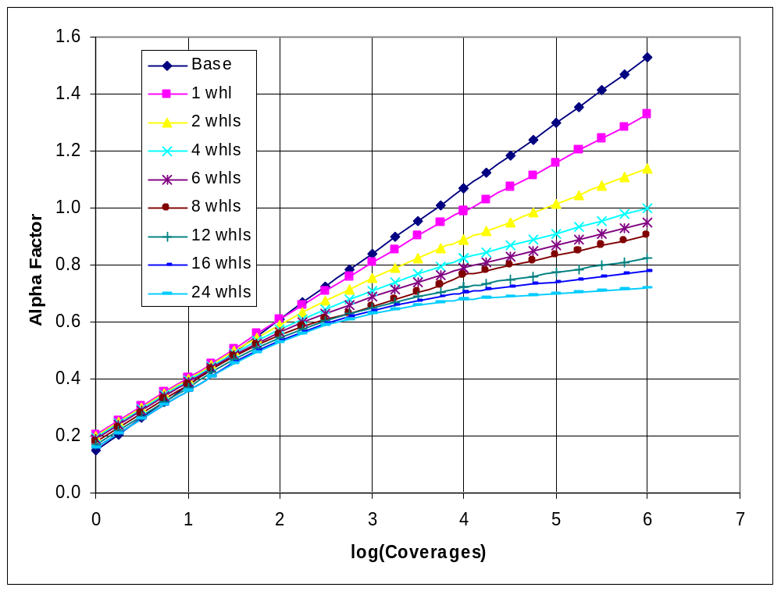
Figure 11. ACN versus log₁₀(Coverages) as implemented in Computer Program F806FAA.

The same equations were implemented in the computer program COMFAA except that the curve for eight wheels was deleted because it does not have the same trend as the other curves and does not fit uniformly between the six- and twelve-wheel curves. To find the Alpha Factor for a number of wheels other than those in the F806FAA set, COMFAA does a cubic spline fit through the defined Alpha Factor curve values at the log₁₀(Coverages) of interest and then interpolates at the desired number of wheels. COMFAA is therefore compatible with the previous FAA methods for flexible pavement design by the CBR method but is applicable in a consistent manner for pavement design with any number of wheels up to a maximum of twenty four. Now that the defined Alpha Factors at 10,000 Coverages have changed for ACN computation, the thickness design portion of COMFAA has to be modified to be compatible with the ACN portion.

As described in references 9 and 10, and from ICAO panel deliberations, the new Alpha Factors at 10,000 Coverages for four- and six-wheel gears were derived from quadratic curve fits to the full-scale test data. These curve fits are only valid within the range of the test data and an alternative procedure has been developed to extrapolate outside the range of the test data in a simple and consistent manner.

Tables 3 and 4 show the full-scale test data from references 4 and 10 used to determine the Alpha Factor curves for an assumed equivalency of 1.4 between standard quality base and subbase materials (data for SQS = 1.4 × CA in reference 10).

Table 3. Alpha Factor versus Coverages from four-wheel full-scale test data.
Test Series | Coverages to Failure | log₁₀(Coverages) | Alpha Factor
MWHGL, 4-Whl | 40 | 1.602 | 0.524
MWHGL, 4-Whl | 40 | 1.602 | 0.538
NAPTF, 4-Whl | 55.9 | 1.747 | 0.634
MWHGL, 4-Whl | 280 | 2.447 | 0.621
NAPTF, 4-Whl | 1,258 | 3.100 | 0.745
NAPTF, 4-Whl | 5,825 | 3.765 | 0.818
NAPTF, 4-Whl | 9,223 | 3.965 | 0.774
NAPTF, 4-Whl | 16,949 | 4.229 | 0.803

Table 4. Alpha Factor versus Coverages from six-wheel full-scale test data.
Test Series | Coverages to Failure | log₁₀(Coverages) | Alpha Factor
MWHGL, 6-Whl | 8 | 0.903 | 0.362
NAPTF, 6-Whl | 57.3 | 1.758 | 0.517
MWHGL, 6-Whl | 104 | 2.017 | 0.572
NAPTF, 6-Whl | 1,009 | 3.004 | 0.645
MWHGL, 6-Whl | 1,500 | 3.176 | 0.667
MWHGL, 6-Whl | 1,500 | 3.176 | 0.684
NAPTF, 6-Whl | 8,280 | 3.918 | 0.736
NAPTF, 6-Whl | 12,739 | 4.105 | 0.693

The curve fitting computer program CurveExpert 1.3 was used to select the best fitting function in terms of goodness of fit and applicability to representing Alpha Factor as a function of log₁₀(Coverages) for pavement design. The function selected is called Exponential Association (3) in the CurveExpert program and is defined by equation 11.

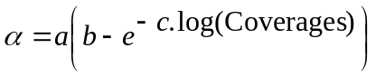 (11)

Figures 12 and 13 show screen shots of the output from the program. The coefficients a, b, and c corresponding to figures 12 and 13 are listed in table 5.

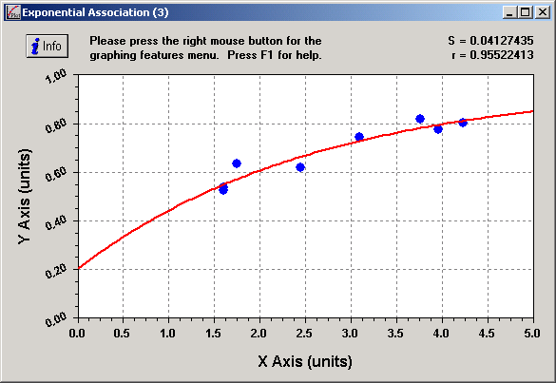
Figure 12. Four-wheel Alpha Factor versus log₁₀(Coverages) from curve fit program for the exponential association (3) function.

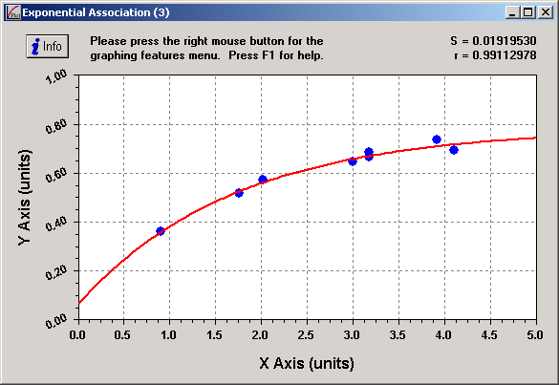
Figure 13. Six-wheel Alpha Factor versus log₁₀(Coverages) from curve fit program for the exponential association (3) function.

Table 5. Coefficients for the exponential association (3) function curve fits in figures 12 and 13.
Coefficient | Four-Wheel Data | Six-Wheel Data
a | 0.759554 | 0.714537
b | 1.269902 | 1.093644
c | 0.378882 | 0.586352

Figure 14 shows the two curves plotted on the same graph together with the base curve from figure 11 and the quadratic curves from reference 10. It can be seen that the exponential association curves agree very well with the quadratic curves over the range of the full-scale test data (about 10 to 15,000 Coverages, or 1 to 4.2 log₁₀(Coverages)). But outside the range of the test data the two sets of curves diverge significantly. Coverage levels below 10 are of relatively little interest, particularly for commercial operations. Coverage levels from 15,000 to 100,000, and higher, are, however, well within normal commercial operations at large airports and figure 14 demonstrates clearly that the quadratic curves are not suitable for extrapolation outside the range of the test data. The design program F806FAA extrapolates outside the range of the test data with linear functions of log₁₀(Coverages) and it is considered that this is a reasonable strategy at low coverage levels. But at high coverage levels it seems more reasonable to continue the curved characteristic, as long as the slope does not become negative as can happen with the quadratic curves. The exponential association curve has a very simple and well defined characteristic at all coverage levels beyond 10,000 when constrained to pass through a defined Alpha Factor at 10,000 Coverages. On this basis, and considering that it appears to be a physically reasonable continuation of the existing test data, the exponential association curve was selected for extrapolation at high coverage levels.

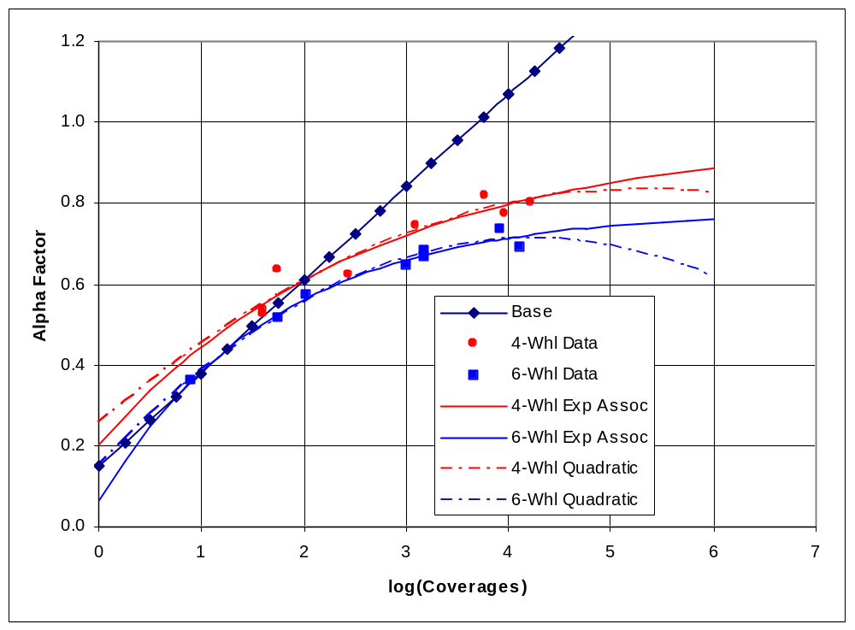
Figure 14. Four- and six-wheel Alpha Factor versus log₁₀(Coverages) showing raw data and quadratic and exponential association (3) curves.

In order to make the COMFAA thickness designs compatible with the Alpha Factor values at 10,000 Coverages of table 2, the exponential association curve for any number of wheels is constrained to pass through the point defined by the Alpha Factor value in the table (or linearly interpolated from the values in the table) and log₁₀(Coverages) = 4.0. At the low end, the curves for all numbers of wheels are constrained to pass through the points log₁₀(Coverages) = 0.0, Alpha Factor = 0.1, and log₁₀(Coverages) = 1.0, Alpha Factor = 0.38.

3.1 DERIVATION OF THE CONSTRAINT EQUATIONS. The Alpha Factor versus Coverages curve is defined by:

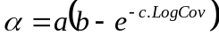 (11)

Where:

α = | Alpha Factor
a, b, and c = | curve fitting coefficients
LogCov = | log₁₀(Coverages)

When Coverages = 1.0, LogCov = 0.0, α₀ = a(b – 1), and

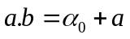 (12)

When Coverages = 10, LogCov = 1.0, and

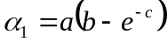 (13)

When Coverages = 10,000, LogCov = 4.0, and

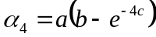 (14)

where α₄ is found from table 2 for the number of wheels of interest.

Rearranging equation 13 and substituting for a.b from equation 12 gives:

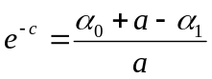
and 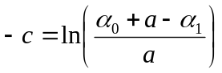 (15)

Rearranging equation 14 and substituting for a.b from equation 12 gives:

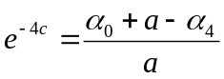
and 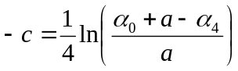 (16)

Subtracting equation 16 from equation 15 gives:

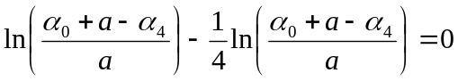 (17)

Equation 17 can be solved iteratively for the coefficient a. Coefficient b is then found from equation 12, c is found from equation 15 or 16, and the Alpha Factor for the number of wheels of interest at LogCov log₁₀(Coverages) is found from equation 11. A Visual Basic function routine implementing this procedure is listed in Appendix A.

Figure 15 shows the new Alpha Factor curves versus log₁₀(Coverages) for four-, and six-wheel gears. The raw data for the single-wheel test data from reference 2 has also been included in the figure (see table 5) and extrapolation below log₁₀(Coverages) = 1.0 is along the Base curve. In comparison with the best fit curves of figure 14, the six-wheel curve in figure 15 is almost identical with that of figure 14. The four-wheel curves in figures 14 and 15 correspond closely above 1,000 Coverages, but diverge below that value. The four-wheel curve in figure 15 could be made to match better with that in figure 14 below 1,000 Coverages by making α₁ a function of the number of wheels to provide a spread in the curves similar to that shown in figure 11. However, this would probably be an unnecessary complication. Quoting again from reference 4, page 71: “The unique limiting curve shown [in figure 82] from 1 to 100 passes represents a composite of the single, twin-tandem, and 12-wheel curves shown in figure 80. Actually, the composite curve for the very low operational level is used for convenience because there is such a small difference in repetitions effect and because it is difficult to differentiate failure at a low operational level.” The wide scatter of the single-wheel raw data seen in figure 15 at low Coverages supports these comments.

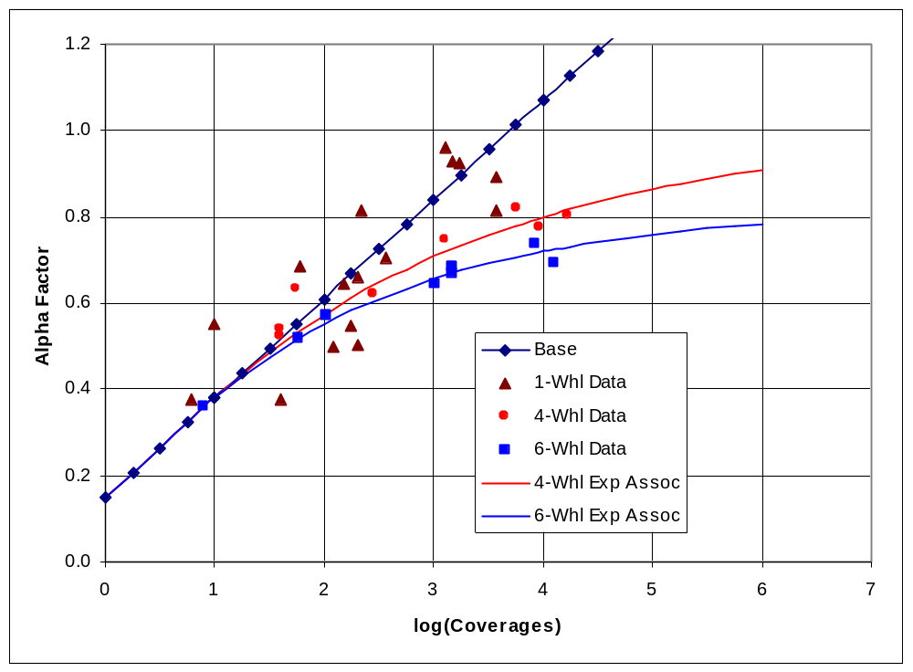
Figure 15. Four- and six-wheel Alpha Factor versus log₁₀(Coverages) showing raw data and constrained exponential association (3) curves.

Table 5. Alpha Factors versus Coverages from single-wheel full-scale test data (reference 2).
Wheel Load, kips | Subgrade CBR | Coverages to Failure | log₁₀(Coverages) | Alpha Factor
200 | 6.0 | 150 | 2.176 | 0.646
200 | 9.0 | 1,700 | 3.230 | 0.924
200 | 16.0 | 10 | 1.000 | 0.550
200 | 18.0 | 60 | 1.778 | 0.686
200 | 15.5 | 360 | 2.556 | 0.704
200 | 17.5 | 1,500 | 3.176 | 0.930
200 | 8.0 | 1,300 | 3.114 | 0.959
15 | 8.0 | 3,760 | 3.575 | 0.813
15 | 9.0 | 3,760 | 3.575 | 0.893
50 | 3.7 | 6 | 0.778 | 0.378
50 | 4.4 | 200 | 2.301 | 0.662
30 | 3.7 | 120 | 2.079 | 0.497
30 | 14.0 | 216 | 2.334 | 0.816
30 | 7.0 | 178 | 2.250 | 0.548
30 | 6.0 | 203 | 2.307 | 0.502
10 | 6.0 | 40 | 1.602 | 0.376

Figure 16 shows Alpha Factor versus log₁₀(Coverages) for constrained exponential association (3) curves and the corresponding curves from the F806 program (see figure 11). Curves are shown only for the single- and four-wheel gears because the new and old curves for six wheels and higher diverge too much at 10,000 coverages for the shape comparison to have any real meaning. The single-wheel curves are almost identical below 10,000 Coverages and show minimal divergence at higher coverage levels, with the new curve being less conservative than the old curve for thickness design. The four-wheel curves show a similar correspondence except that the divergence above 10,000 Coverages is exaggerated by the enforced difference of 0.25 at 10,000 Coverages.
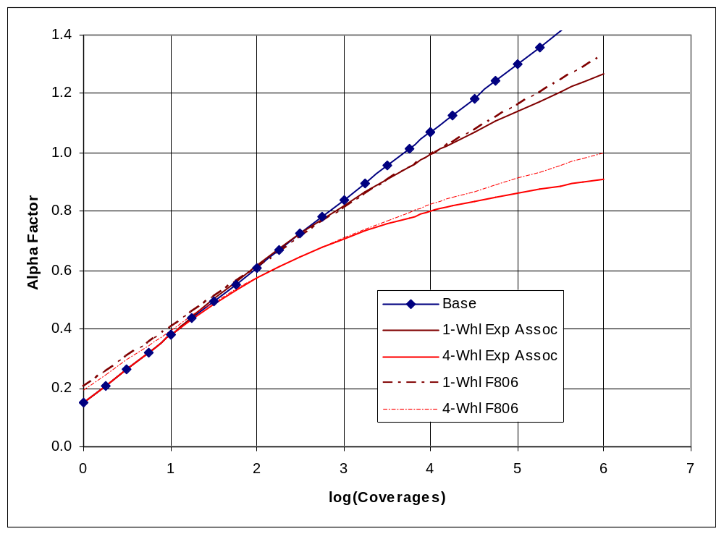
Figure 16. Single- and four-wheel Alpha Factor versus log₁₀(Coverages) showing constrained exponential association (3) curves and the corresponding curves from the F806 program.

Finally, figure 17 shows the family of new Alpha Factor constrained exponential association curves corresponding to the old F806FAA curves shown in figure 11. Curves for any other number of wheels can be found by linear interpolation between the values of Alpha Factor given in table 2 and the application of equation 11 as described above.

For thickness design of flexible pavements, it is recommended that the design be based on that number of wheels which gives the thickest pavement out of all combinations of wheels from the complete main landing gear group. This will maintain compatibility with the CBR flexible pavement thickness design procedure as specified in reference 4.
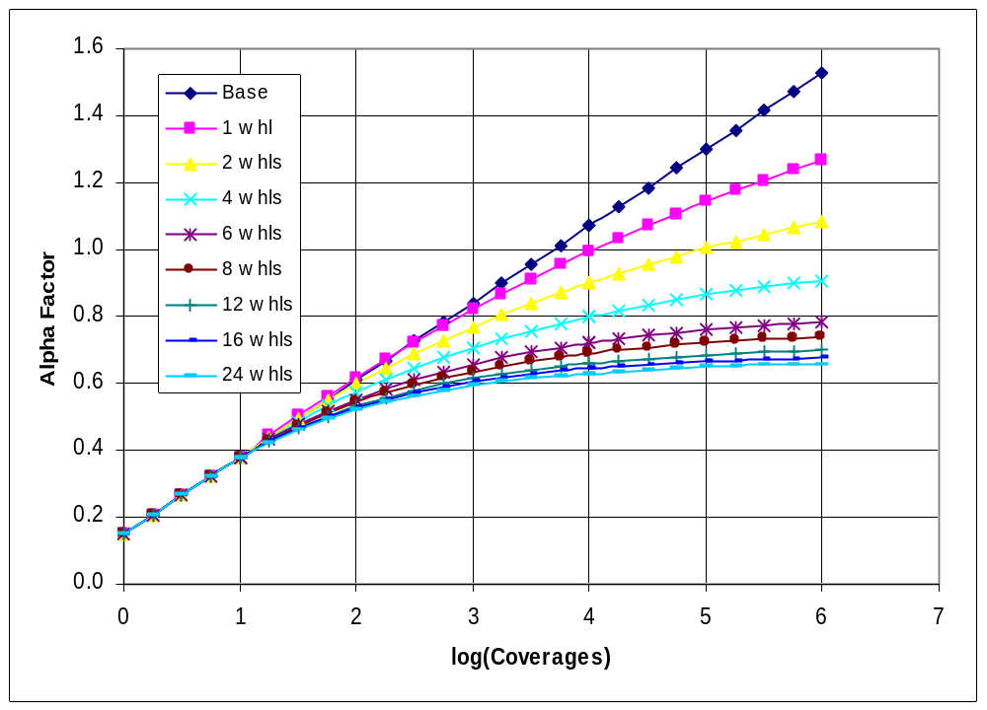
Figure 17. Family of constrained exponential association (3) Alpha Factor versus log₁₀(Coverages) curves for use in COMFAA.

4. SUMMARY.

ICAO has proposed that the Alpha Factors for four- and six-wheel gears at 10,000 Coverages be redefined for use in calculating the ACN of airplanes operating on flexible pavements. The proposed Alpha Factors are 0.800 and 0.720 compared to the existing values of 0.825 and 0.788, with the new values being based on an analysis of an expanded set of full-scale test data for four- and six-wheel traffic. With these changes, Alpha Factors at other numbers of wheels, and over the full range of coverages for design, required redefinition to maintain consistency in the CBR procedure for flexible pavement thickness design as required for ACN calculations, even though additional full-scale test data is not available for other than four- and six-wheel gears. In fact, full-scale test data is not available at all for gears with more than six wheels. The Alpha Factors have been redefined as follows.

- The standard set of Alpha Factors at 10,000 Coverages for 1, 2, 4, 6, 8, 12, 18, and 24 wheels have the new values: 0.995, 0.900, 0.800, 0.720, 0.690, 0.660, 0.640, and 0.630. The values for one and two wheels are unchanged from the old set because the old values were based on existing full-scale test data. The values for more than six wheels were derived based on maintaining a consistent ranking of damaging effect, as recommended in ICAO AOSWG/4 Discussion Paper No. 21. This was done by making the ratio of ACN for the higher numbers of wheels to ACN for six wheels in the new set of values approximately the same as in the old set of values.
- Alpha Factors at 10,000 Coverages for numbers of wheels other than those in the standard set (in item 1 above) should be found by linear interpolation between the two closest numbers of wheels in the standard set.
- It is recommended that the wheel configuration used to compute the ACN for any particular airplane should be selected on the basis of the wheels used in the computation forming a recognizable group, with the spacing between adjacent wheels being about the same for all wheels in the group. This is compatible with current ICAO ACN calculations for multiple-gear airplanes.
- A new set of functions has been established for describing the variation of Alpha Factor with Coverages over the full range of 1 to 24 wheels. The functions are defined by an exponential equation constrained to pass through the points:
  - Alpha Factor as defined in items 1 and 2 above and Coverages = 10,000.
  - Alpha Factor = 0.38 and Coverages = 10.
  - Alpha Factor = 0.1 and Coverages = 0.
- If the new set of functions is to be used for flexible pavement thickness design, it is recommended that the design be based on that number of wheels which gives the thickest pavement out of all combinations of wheels from the complete main landing gear group. This is compatible with the CBR flexible pavement thickness design procedure as recommended by the U.S. Army Corps of Engineers and as implemented by the FAA for multiple-gear airplanes.

5. REFERENCES.

- International Civil Aviation Organization, Doc 9157-AN/901, “Aerodrome Design Manual, Part 3, Pavements,” Montreal Quebec, Canada, Second Edition, 1983.
- Cooksey, D. L., and Ladd, D. M., “Pavement Design for Various Levels of Traffic Volume, AFWL-TR-70-133, prepared by U. S. Army Engineer Waterways Experiment Station, CE, for Air Force Weapons Laboratory, Kirtland AFB, NM, July 1970.
- Pereira, A. Taboza, Instruction Report S-77-1, “Procedures for Development of CBR Design Curves,” U. S. Army Engineer Waterways Experiment Station, CE, June 1977.
- Ahlvin, R. G., Ulery, H. H., Hutchinson, R. L., and Rice, J. L., Technical Report S-71-17, “Multiple-Wheel Heavy Gear Load Pavement Tests, Vol. 1, Basic Report,” U. S. Army Engineer Waterways Experiment Station, CE, June 1971.
- Hayhoe, Gordon F., “Alpha Factor Determination Using Data Collected At The National Airport Pavement Test Facility,” Report DOT/FAA/AR-06/7, March, 2006.
- Rodway, Bruce, Wardle, Leigh, J, and Wickham, Gary, “Interaction Between Wheels and Wheel Groups of New Large Aircraft,” 1999 FAA Airport Technology Transfer Conference, Atlantic City, New Jersey, April, 1999.
- FAA AC 150/5335-5A, “Standardized Method of Reporting Airport Pavement Strength – PCN.”
- FAA Engineering Brief No. 43, “Computerized Pavement Design,” FAA Engineering Specifications Division, AAS-200, April, 1989.
- Hayhoe, Gordon F., “Alpha Factor Determination Using Data Collected at the National Airport Pavement Test Facility,” FAA Report DOT/FAA/AR-06/7, March, 2006.
- Hayhoe, Gordon F., “Subgrade CBR Values for Alpha Factor Determination Using Data Collected at the National Airport Pavement Test Facility,” FAA Technical Note DOT/FAA/TN-07/-, in publication.

APPENDIX A – VISUAL BASIC FUNCTION ROUTINE FOR COMPUTING ALPHA FACTOR

Function New06AlphaFactorFromCurve(NW As Integer, Coverages As Double) As Double

' NW = number of wheels.
Dim I As Long
Dim A As Double, B As Double, C As Double
Dim A0 As Double, A1 As Double, A4 As Double
Dim LogCovA0 As Double, LogCovA1 As Double, LogCovA4 As Double
Dim A4define() As Double, NWA4define() As Long, NA4define As Long
Dim Resid As Double, ResidM1 As Double, DelA As Double, Slope As Double

' Fixed points to define alpha versus log(coverages) curves.
' log(coverage) values.
LogCovA0 = 0: LogCovA1 = 1: LogCovA4 = 4
' Alphas at log(coverages)
A0 = 0.1: A1 = 0.38 ' A4 = derived from new set of alpha at 10,000 coverages.

' Incremental damage relative to six-wheels the same as old alphas for higher than 6-wheels.
NA4define = 8 ' Number of defined values of alpha at 10,000 coverages.
' NWA4define() = number of wheels. A4define = alpha for NWA4define wheels.
ReDim NWA4define(NA4define), A4define(NA4define)
NWA4define(1) = 1: NWA4define(2) = 2: NWA4define(3) = 4
NWA4define(4) = 6: NWA4define(5) = 8: NWA4define(6) = 12
NWA4define(7) = 18: NWA4define(8) = 24
A4define(1) = 0.995: A4define(2) = 0.9: A4define(3) = 0.8
A4define(4) = 0.72: A4define(5) = 0.69: A4define(6) = 0.66
A4define(7) = 0.64: A4define(8) = 0.63

If NW < NWA4define(1) Then ' Should never happen. Would be an error.
New06AlphaFactorFromCurve = A4define(1)
Exit Function
End If

If Coverages < 10 Then ' Lower end of curves is independent of number of wheels.
New06AlphaFactorFromCurve = 0.15 + 0.23 * Log10(Coverages)
Exit Function
End If

' Linear interpolation for undefined alpha factors at 10,000 coverages.
For I = 1 To NA4define - 1
If NW < NWA4define(I + 1) Then
Slope = (A4define(I + 1) - A4define(I)) / _
CDbl(NWA4define(I + 1) - NWA4define(I))
A4 = A4define(I) + Slope * CDbl(NW - NWA4define(I))
Exit For
Else
A4 = A4define(NA4define)
End If
Next I

' Find the coefficients of the defining exponential association (3) curve
' Alpha = A * (B - e^(-C * log10(Coverages))), (see CurveExpert program).
' Solve for Resid function (below) by Newton's method.
A = A4 - A0 + 0.1 ' The second log argument is -ve if A < A4 - A0.
DelA = A / 1000

ResidM1 = Log((A0 + A - A1) / A) / LogCovA1 - Log((A0 + A - A4) / A) / LogCovA4
Do
A = A + DelA
Resid = Log((A0 + A - A1) / A) / LogCovA1 - Log((A0 + A - A4) / A) / LogCovA4
A = A - Resid * DelA / (Resid - ResidM1)
If A < A4 - A0 + 0.001 Then
A = A4 - A0 + 0.001 ' Jumped too far because of nonlinearity.
End If
ResidM1 = Log((A0 + A - A1) / A) / LogCovA1 - Log((A0 + A - A4) / A) / LogCovA4
DoEvents ' In case the iteration does not terminate. Allows interruption.
Loop Until Abs(ResidM1) < 0.000001

B = A0 / A + 1
C = -Log((A0 + A - A4) / A) / LogCovA4

New06AlphaFactorFromCurve = A * (B - Exp(-C * Log10(Coverages)))

End Function

